ASSIGNMENT 7.3

Write a custom key to evaluate the number of people who died and the number of people who survived, along with their genders.

CODE :

DRIVER CLASS

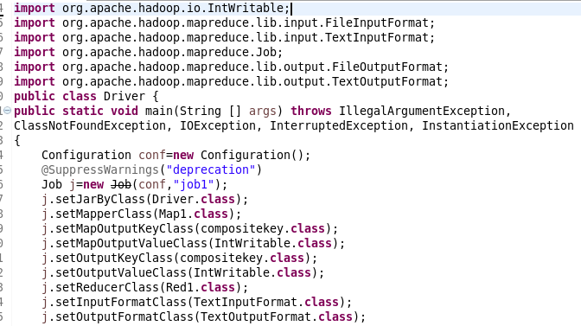

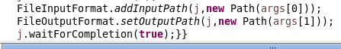

MAPPER CLASS

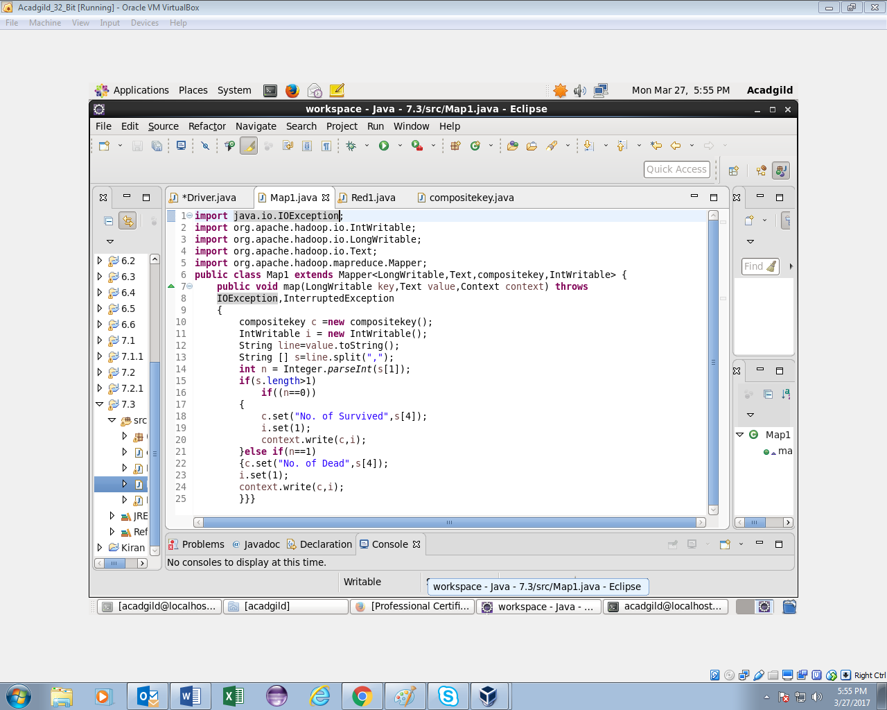

REDUCER CLASS

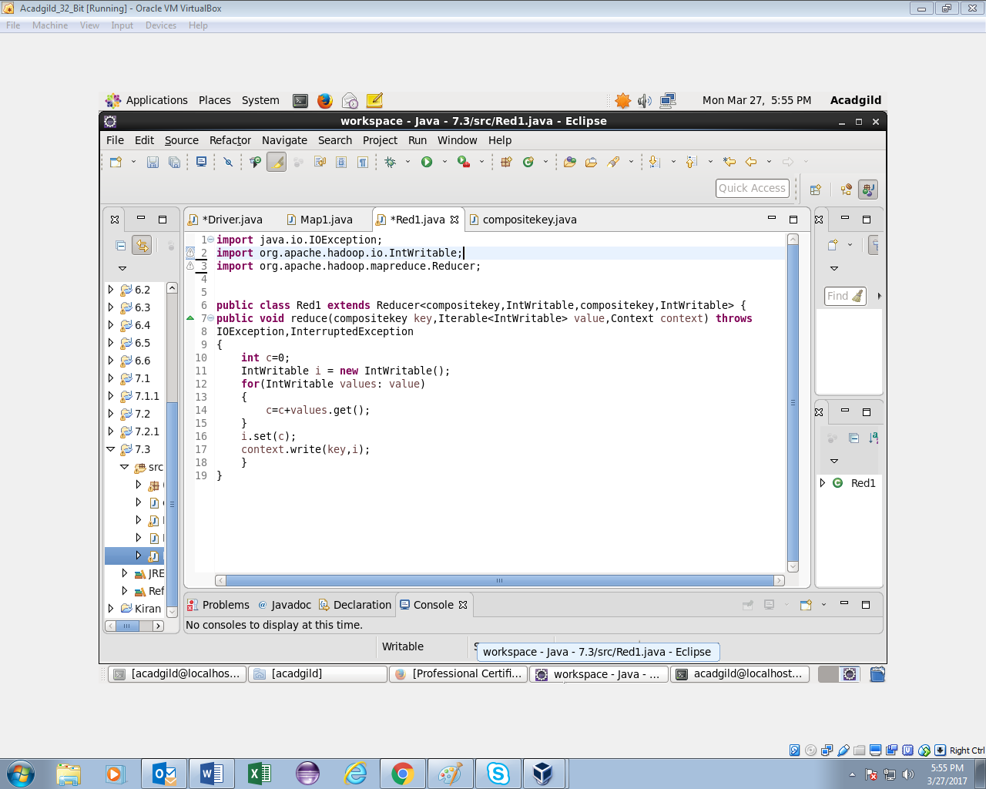

COMPOSITEKEY CLASS :

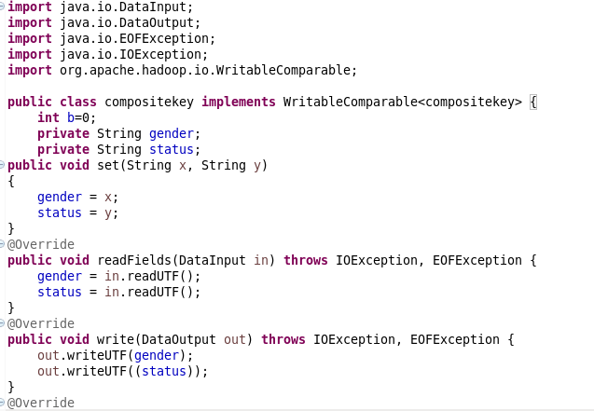 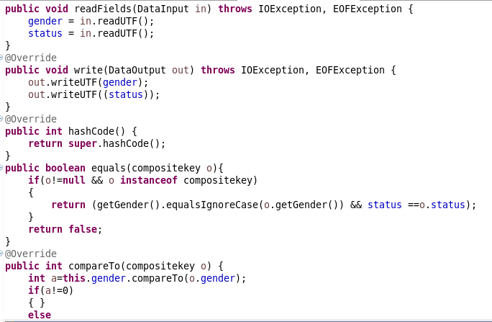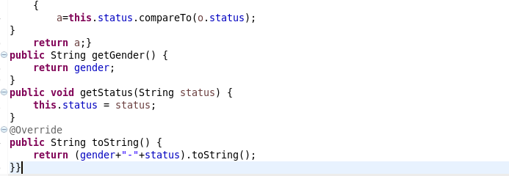

OUTPUT:

